**1. Functional document**

**1.1 Business goal**

The purpose of this application is to manage all the content files according to type and details etc. These files are stored in a shared location and can be accessed by all the colleagues.

**1.2 Target audience**

This application will be used in our company in order to easily the access to a specific file.

**1.3 General requirements**

In the application the users can do the following things:

* Copy the files from now on into a new location “Drop folder”.
* After the files were copied ,the application can do the following operations:
* Organize them about type and put every type in a folder(remote location)
* For every file moved ,a record in the database will be added
* In database will be also stored the details about files
* The users can also see the detail about the files that have been stored
* The application should reside in the system tray

The functional modules can be the followings:

**Search module** – The search results should be shown in a preview screen, displaying the thumbnails of files if possible. Scrolling through the files should be easy and intuitive (tooltip preview with summary metadata)

**Open module**

- Open the file location and select file. In order to do this the user can right click on the file and a menu will appear, and he can choose the option ‘Open file location’ in order to see in which folder is the file. If the file is selected, a preview windows appear with the detail about this file

**Delete module**

In this module the user can delete a file from database and from context if the right click is pressed and the option ‘Delete’ is selected

**Upload module**

The user can Upload a file to database and also add custom metadata to this file

- The user has the option to choose the location where to be copied the file

**1.5 Use case scenarios**

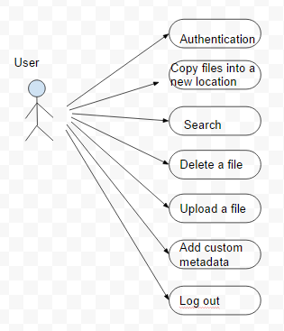

**1.6 Non - functional requirements**

* The application should provide a friendly interface with the users
* The application should work on any browser

**2. Technical document**

**2.1 Database model**

